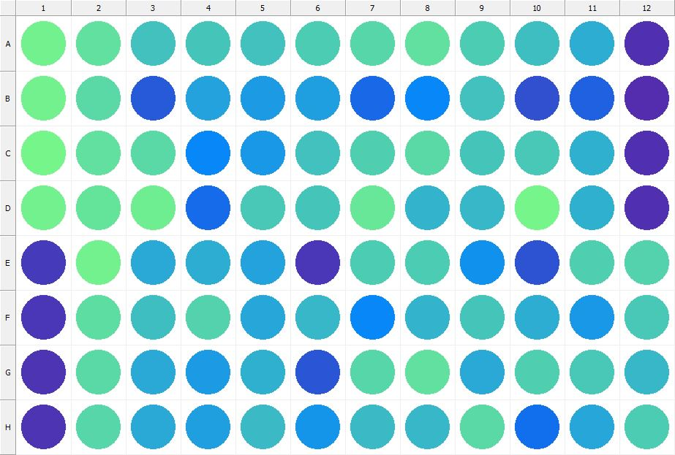

|  |
| --- |
| **Results for Tim_CTB(1) - channel 1 (RFU)** |

|  |  |  |  |  |  |  |  |  |  |  |  |  |
| --- | --- | --- | --- | --- | --- | --- | --- | --- | --- | --- | --- | --- |
|  | 01 | 02 | 03 | 04 | 05 | 06 | 07 | 08 | 09 | 10 | 11 | 12 |
| A | 162974 | 151675 | 130688 | 133368 | 130282 | 136943 | 144520 | 151692 | 136784 | 127301 | 114851 | 31501 |
| B | 163485 | 146997 | 59805 | 110133 | 103836 | 107738 | 70022 | 89312 | 130434 | 53974 | 65792 | 30907 |
| C | 165291 | 151924 | 146800 | 90587 | 103032 | 130884 | 139036 | 145283 | 133264 | 135671 | 119147 | 31896 |
| D | 162057 | 152403 | 160040 | 71409 | 135548 | 133016 | 155867 | 120648 | 123332 | 165630 | 117159 | 31870 |
| E | 39375 | 163060 | 112723 | 116788 | 109594 | 38257 | 137366 | 136372 | 98474 | 56068 | 138049 | 141856 |
| F | 38057 | 148051 | 127407 | 142272 | 112396 | 121923 | 89516 | 121769 | 131343 | 116542 | 101796 | 133493 |
| G | 34553 | 146056 | 113590 | 105180 | 119086 | 57615 | 144424 | 150804 | 113963 | 138166 | 134920 | 123166 |
| H | 35870 | 142943 | 114263 | 106208 | 125025 | 99920 | 125159 | 121895 | 145727 | 73243 | 110703 | 136080 |

|  |  |
| --- | --- |
| **Plate information** | |
|  | |
| **Plate** | 1 |
| **Repeat** | 1 |
| **Barcode** |  |
| **Measured height** | 14.78 |
| **Inside temperature at start** | 23.73 |
| **Inside temperature at end** | 23.73 |
| **Humidity at start** | 16.2 |
| **Humidity at end** | 15.9 |
| **Ambient temperature at start** | 23.44 |
| **Ambient temperature at end** | 23.54 |
| **Group** | 1 |
| **Label** | Tim_CTB(1) |
| **ScanX** | 0 |
| **ScanY** | 0 |
| **Measinfo** | De=1st Ex=Top Em=Top Wdw=N/A (14) |
| **Kinetics** | 0 |
| **Measurement date** | 11/21/2022 1:57:09 PM |
|  | |

|  |
| --- |
| **Background information** |
| Legend:  HDR1 - Plate  HDR2 - Label  HDR3 - Result  HDR4 - Signal  HDR5 - Flashes/Time  HDR6 - Meastime  HDR7 - MeasInfo |
| HDR1 HDR2 HDR3 HDR4 HDR5 HDR6 HDR7  1 Tim_CTB 0 1063 1 00:00:00.000 De=1st Ex=Top Em=Top Wdw=N/A (14) |
|  |

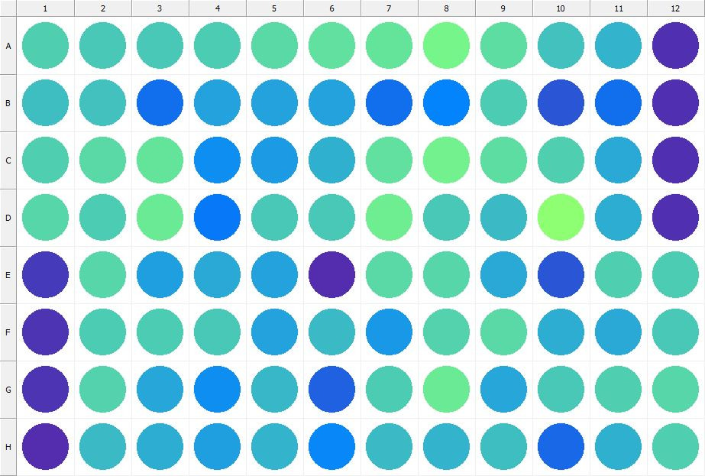

|  |
| --- |
| **Results for Tim_CTB(1) - channel 1 (RFU)** |

|  |  |  |  |  |  |  |  |  |  |  |  |  |
| --- | --- | --- | --- | --- | --- | --- | --- | --- | --- | --- | --- | --- |
|  | 01 | 02 | 03 | 04 | 05 | 06 | 07 | 08 | 09 | 10 | 11 | 12 |
| A | 139602 | 133910 | 135487 | 135928 | 146639 | 151838 | 152785 | 164066 | 148195 | 130075 | 121651 | 32485 |
| B | 127868 | 129484 | 73773 | 108397 | 109084 | 109290 | 74335 | 87350 | 135808 | 57792 | 73736 | 31678 |
| C | 139429 | 146165 | 152628 | 95264 | 105072 | 119417 | 150237 | 162672 | 148618 | 140144 | 112994 | 32133 |
| D | 143365 | 137199 | 156969 | 80624 | 134159 | 134579 | 160991 | 134189 | 125400 | 180813 | 116444 | 31894 |
| E | 39332 | 143414 | 106845 | 113981 | 109682 | 30425 | 146773 | 144204 | 114738 | 57623 | 139719 | 135885 |
| F | 33945 | 136559 | 136339 | 135490 | 110082 | 125384 | 101506 | 141642 | 146431 | 116933 | 113171 | 135539 |
| G | 34529 | 142281 | 111550 | 94916 | 121888 | 64631 | 137405 | 158383 | 112220 | 134286 | 139221 | 143412 |
| H | 31166 | 125104 | 116724 | 107201 | 120191 | 89714 | 124500 | 119660 | 126784 | 69490 | 118114 | 139036 |

|  |  |
| --- | --- |
| **Plate information** | |
|  | |
| **Plate** | 2 |
| **Repeat** | 1 |
| **Barcode** |  |
| **Measured height** | 14.78 |
| **Inside temperature at start** | 23.73 |
| **Inside temperature at end** | 23.73 |
| **Humidity at start** | 15.4 |
| **Humidity at end** | 15.5 |
| **Ambient temperature at start** | 23.54 |
| **Ambient temperature at end** | 23.54 |
| **Group** | 1 |
| **Label** | Tim_CTB(1) |
| **ScanX** | 0 |
| **ScanY** | 0 |
| **Measinfo** | De=1st Ex=Top Em=Top Wdw=N/A (14) |
| **Kinetics** | 0 |
| **Measurement date** | 11/21/2022 1:57:51 PM |
|  | |

|  |
| --- |
| **Background information** |
| Legend:  HDR1 - Plate  HDR2 - Label  HDR3 - Result  HDR4 - Signal  HDR5 - Flashes/Time  HDR6 - Meastime  HDR7 - MeasInfo |
| HDR1 HDR2 HDR3 HDR4 HDR5 HDR6 HDR7  2 Tim_CTB 0 1146 1 00:00:00.000 De=1st Ex=Top Em=Top Wdw=N/A (14) |
|  |

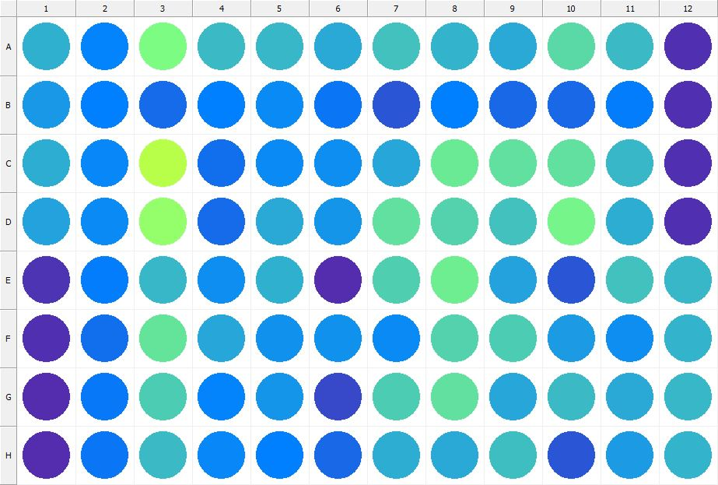

|  |
| --- |
| **Results for Tim_CTB(1) - channel 1 (RFU)** |

|  |  |  |  |  |  |  |  |  |  |  |  |  |
| --- | --- | --- | --- | --- | --- | --- | --- | --- | --- | --- | --- | --- |
|  | 01 | 02 | 03 | 04 | 05 | 06 | 07 | 08 | 09 | 10 | 11 | 12 |
| A | 117725 | 87502 | 168674 | 126024 | 122745 | 114332 | 129548 | 120961 | 113984 | 145913 | 125071 | 31551 |
| B | 102670 | 86276 | 71538 | 86714 | 93592 | 78252 | 58317 | 85329 | 70350 | 69320 | 82946 | 31535 |
| C | 117126 | 89915 | 209814 | 74797 | 92507 | 95982 | 111115 | 157447 | 151590 | 150131 | 123543 | 31701 |
| D | 109819 | 92720 | 184645 | 71192 | 113716 | 98933 | 151746 | 142558 | 130491 | 165191 | 115603 | 32357 |
| E | 35277 | 83612 | 122105 | 95703 | 118629 | 30268 | 140324 | 159556 | 109766 | 57449 | 129873 | 122568 |
| F | 31538 | 74153 | 152985 | 111487 | 96654 | 97214 | 93907 | 140782 | 135782 | 105243 | 94183 | 120510 |
| G | 31055 | 80584 | 137027 | 87692 | 99593 | 49567 | 137278 | 149675 | 111966 | 124525 | 114072 | 123254 |
| H | 30155 | 77961 | 125596 | 91551 | 86804 | 70641 | 115680 | 113969 | 127475 | 57403 | 103943 | 120266 |

|  |  |
| --- | --- |
| **Plate information** | |
|  | |
| **Plate** | 3 |
| **Repeat** | 1 |
| **Barcode** |  |
| **Measured height** | 14.78 |
| **Inside temperature at start** | 23.73 |
| **Inside temperature at end** | 23.73 |
| **Humidity at start** | 15.4 |
| **Humidity at end** | 15.5 |
| **Ambient temperature at start** | 23.64 |
| **Ambient temperature at end** | 23.64 |
| **Group** | 1 |
| **Label** | Tim_CTB(1) |
| **ScanX** | 0 |
| **ScanY** | 0 |
| **Measinfo** | De=1st Ex=Top Em=Top Wdw=N/A (14) |
| **Kinetics** | 0 |
| **Measurement date** | 11/21/2022 1:58:39 PM |
|  | |

|  |
| --- |
| **Background information** |
| Legend:  HDR1 - Plate  HDR2 - Label  HDR3 - Result  HDR4 - Signal  HDR5 - Flashes/Time  HDR6 - Meastime  HDR7 - MeasInfo |
| HDR1 HDR2 HDR3 HDR4 HDR5 HDR6 HDR7  3 Tim_CTB 0 1115 1 00:00:00.000 De=1st Ex=Top Em=Top Wdw=N/A (14) |
|  |

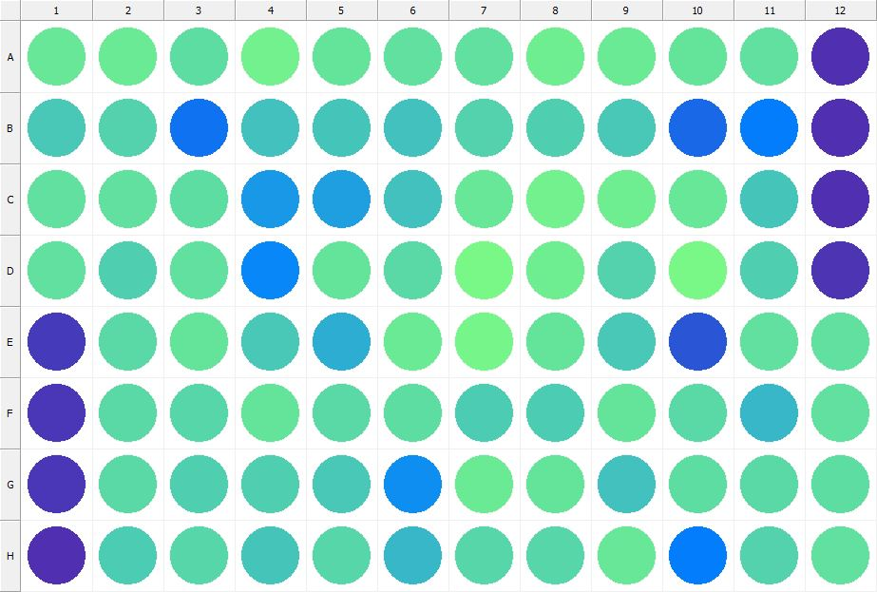

|  |
| --- |
| **Results for Tim_CTB(1) - channel 1 (RFU)** |

|  |  |  |  |  |  |  |  |  |  |  |  |  |
| --- | --- | --- | --- | --- | --- | --- | --- | --- | --- | --- | --- | --- |
|  | 01 | 02 | 03 | 04 | 05 | 06 | 07 | 08 | 09 | 10 | 11 | 12 |
| A | 154760 | 157487 | 149086 | 163085 | 151958 | 150417 | 149811 | 160512 | 157134 | 153235 | 150783 | 33617 |
| B | 134954 | 142209 | 76724 | 128746 | 131646 | 130669 | 140361 | 139109 | 134521 | 69020 | 83121 | 32648 |
| C | 149684 | 150663 | 149551 | 101568 | 106915 | 130397 | 154965 | 162447 | 160712 | 154913 | 132913 | 32713 |
| D | 149643 | 138252 | 151167 | 91026 | 152451 | 145264 | 166365 | 159063 | 141163 | 166819 | 139723 | 34657 |
| E | 39174 | 146016 | 152931 | 135475 | 115355 | 158835 | 165338 | 152185 | 134676 | 59086 | 149738 | 151192 |
| F | 36258 | 145151 | 143971 | 152392 | 145218 | 147966 | 137543 | 136336 | 153906 | 145176 | 122367 | 150349 |
| G | 35980 | 146600 | 139698 | 138368 | 135562 | 94733 | 158387 | 153065 | 129973 | 147921 | 145436 | 148408 |
| H | 32508 | 137423 | 142783 | 131832 | 143430 | 123027 | 143524 | 142922 | 154460 | 82526 | 141890 | 151763 |

|  |  |
| --- | --- |
| **Plate information** | |
|  | |
| **Plate** | 4 |
| **Repeat** | 1 |
| **Barcode** |  |
| **Measured height** | 14.78 |
| **Inside temperature at start** | 23.73 |
| **Inside temperature at end** | 23.75 |
| **Humidity at start** | 15.4 |
| **Humidity at end** | 15.4 |
| **Ambient temperature at start** | 23.54 |
| **Ambient temperature at end** | 23.56 |
| **Group** | 1 |
| **Label** | Tim_CTB(1) |
| **ScanX** | 0 |
| **ScanY** | 0 |
| **Measinfo** | De=1st Ex=Top Em=Top Wdw=N/A (14) |
| **Kinetics** | 0 |
| **Measurement date** | 11/21/2022 1:59:18 PM |
|  | |

|  |
| --- |
| **Background information** |
| Legend:  HDR1 - Plate  HDR2 - Label  HDR3 - Result  HDR4 - Signal  HDR5 - Flashes/Time  HDR6 - Meastime  HDR7 - MeasInfo |
| HDR1 HDR2 HDR3 HDR4 HDR5 HDR6 HDR7  4 Tim_CTB 0 1086 1 00:00:00.000 De=1st Ex=Top Em=Top Wdw=N/A (14) |
|  |

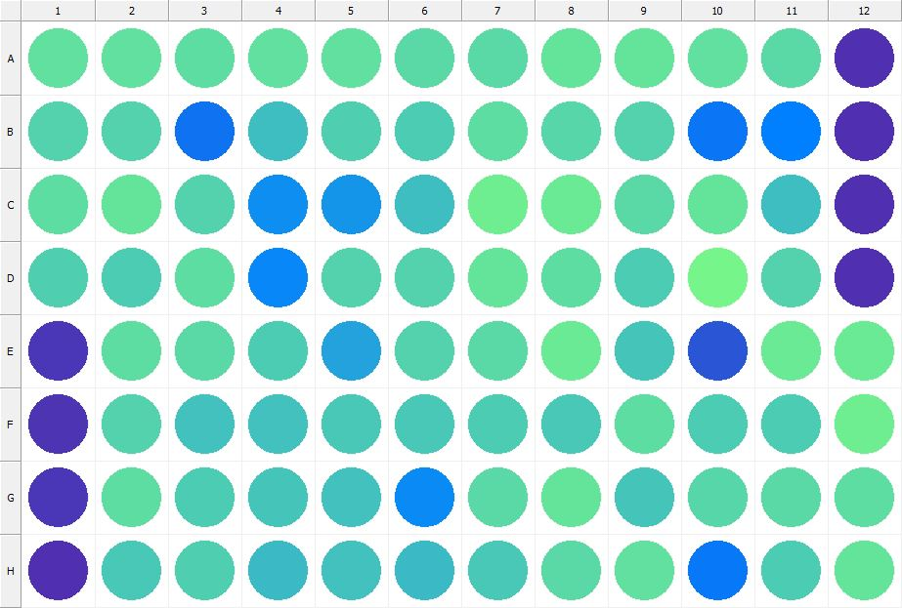

|  |
| --- |
| **Results for Tim_CTB(1) - channel 1 (RFU)** |

|  |  |  |  |  |  |  |  |  |  |  |  |  |
| --- | --- | --- | --- | --- | --- | --- | --- | --- | --- | --- | --- | --- |
|  | 01 | 02 | 03 | 04 | 05 | 06 | 07 | 08 | 09 | 10 | 11 | 12 |
| A | 149824 | 151804 | 149226 | 151126 | 150674 | 146519 | 147143 | 151978 | 153031 | 151518 | 145169 | 32373 |
| B | 141721 | 142094 | 77334 | 127706 | 138095 | 136361 | 149346 | 144878 | 140674 | 79468 | 86464 | 31968 |
| C | 147499 | 152988 | 140564 | 94791 | 100465 | 127997 | 159063 | 158366 | 147109 | 152926 | 127291 | 33020 |
| D | 138632 | 137135 | 147553 | 89689 | 140400 | 141139 | 153643 | 148984 | 137601 | 164206 | 142539 | 33467 |
| E | 37591 | 147793 | 146364 | 137028 | 107971 | 141952 | 146270 | 156940 | 132216 | 57595 | 157962 | 158232 |
| F | 33915 | 142277 | 129084 | 130109 | 133523 | 134331 | 137878 | 134248 | 148965 | 137501 | 135793 | 159612 |
| G | 37617 | 149260 | 136746 | 131631 | 129015 | 93818 | 146036 | 152040 | 131281 | 144727 | 145561 | 147655 |
| H | 31802 | 134058 | 139109 | 125868 | 130641 | 124112 | 134667 | 146658 | 149679 | 81544 | 136761 | 152305 |

|  |  |
| --- | --- |
| **Plate information** | |
|  | |
| **Plate** | 5 |
| **Repeat** | 1 |
| **Barcode** |  |
| **Measured height** | 14.78 |
| **Inside temperature at start** | 23.83 |
| **Inside temperature at end** | 23.85 |
| **Humidity at start** | 15.1 |
| **Humidity at end** | 15.4 |
| **Ambient temperature at start** | 23.44 |
| **Ambient temperature at end** | 23.56 |
| **Group** | 1 |
| **Label** | Tim_CTB(1) |
| **ScanX** | 0 |
| **ScanY** | 0 |
| **Measinfo** | De=1st Ex=Top Em=Top Wdw=N/A (14) |
| **Kinetics** | 0 |
| **Measurement date** | 11/21/2022 1:59:56 PM |
|  | |

|  |
| --- |
| **Background information** |
| Legend:  HDR1 - Plate  HDR2 - Label  HDR3 - Result  HDR4 - Signal  HDR5 - Flashes/Time  HDR6 - Meastime  HDR7 - MeasInfo |
| HDR1 HDR2 HDR3 HDR4 HDR5 HDR6 HDR7  5 Tim_CTB 0 1130 1 00:00:00.000 De=1st Ex=Top Em=Top Wdw=N/A (14) |
|  |

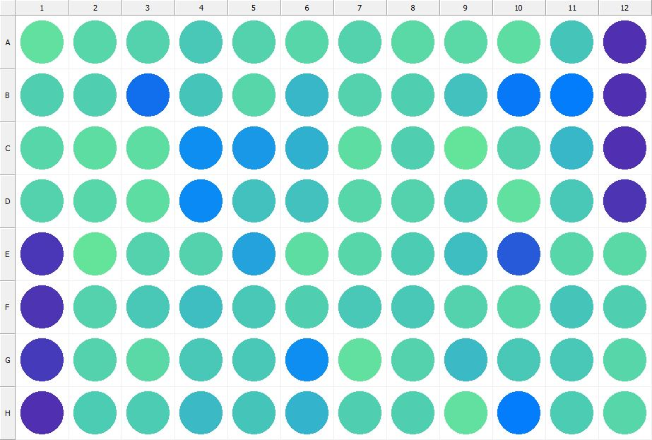

|  |
| --- |
| **Results for Tim_CTB(1) - channel 1 (RFU)** |

|  |  |  |  |  |  |  |  |  |  |  |  |  |
| --- | --- | --- | --- | --- | --- | --- | --- | --- | --- | --- | --- | --- |
|  | 01 | 02 | 03 | 04 | 05 | 06 | 07 | 08 | 09 | 10 | 11 | 12 |
| A | 151225 | 143343 | 141216 | 133978 | 140369 | 143289 | 141493 | 146769 | 147201 | 147782 | 132144 | 33545 |
| B | 140282 | 140179 | 75278 | 133300 | 144070 | 122205 | 142514 | 138151 | 130433 | 80975 | 84340 | 32440 |
| C | 143849 | 149026 | 148529 | 95909 | 102778 | 118510 | 148105 | 139338 | 152283 | 141779 | 122663 | 33103 |
| D | 140593 | 143973 | 147493 | 92576 | 130648 | 130402 | 143864 | 141183 | 134718 | 151357 | 135599 | 34032 |
| E | 38114 | 152013 | 141218 | 140483 | 110162 | 148823 | 143948 | 136208 | 128303 | 59389 | 142949 | 146938 |
| F | 34946 | 140671 | 134814 | 128680 | 133525 | 138916 | 133447 | 133788 | 140829 | 143098 | 131425 | 140189 |
| G | 39772 | 141938 | 146391 | 135686 | 134868 | 95824 | 150655 | 142504 | 125419 | 134245 | 135357 | 144052 |
| H | 33042 | 136263 | 136728 | 126208 | 132160 | 120467 | 139791 | 138105 | 149951 | 82830 | 137570 | 144216 |

|  |  |
| --- | --- |
| **Plate information** | |
|  | |
| **Plate** | 6 |
| **Repeat** | 1 |
| **Barcode** |  |
| **Measured height** | 14.78 |
| **Inside temperature at start** | 23.83 |
| **Inside temperature at end** | 23.83 |
| **Humidity at start** | 15.2 |
| **Humidity at end** | 15.2 |
| **Ambient temperature at start** | 23.64 |
| **Ambient temperature at end** | 23.64 |
| **Group** | 1 |
| **Label** | Tim_CTB(1) |
| **ScanX** | 0 |
| **ScanY** | 0 |
| **Measinfo** | De=1st Ex=Top Em=Top Wdw=N/A (14) |
| **Kinetics** | 0 |
| **Measurement date** | 11/21/2022 2:00:40 PM |
|  | |

|  |
| --- |
| **Background information** |
| Legend:  HDR1 - Plate  HDR2 - Label  HDR3 - Result  HDR4 - Signal  HDR5 - Flashes/Time  HDR6 - Meastime  HDR7 - MeasInfo |
| HDR1 HDR2 HDR3 HDR4 HDR5 HDR6 HDR7  6 Tim_CTB 0 1106 1 00:00:00.000 De=1st Ex=Top Em=Top Wdw=N/A (14) |
|  |

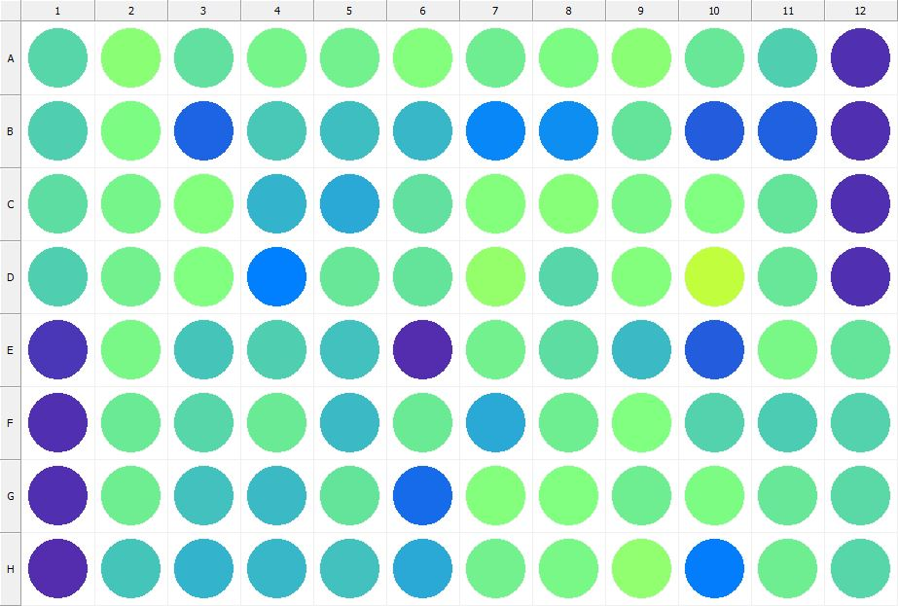

|  |
| --- |
| **Results for Tim_CTB(1) - channel 1 (RFU)** |

|  |  |  |  |  |  |  |  |  |  |  |  |  |
| --- | --- | --- | --- | --- | --- | --- | --- | --- | --- | --- | --- | --- |
|  | 01 | 02 | 03 | 04 | 05 | 06 | 07 | 08 | 09 | 10 | 11 | 12 |
| A | 142915 | 177709 | 151375 | 165465 | 162668 | 173951 | 159018 | 170120 | 178767 | 154298 | 139830 | 33139 |
| B | 139129 | 168649 | 67207 | 135283 | 126921 | 122039 | 91182 | 94940 | 153457 | 63301 | 65638 | 31712 |
| C | 149509 | 163673 | 173428 | 120023 | 112950 | 149763 | 174465 | 175573 | 167877 | 171902 | 153557 | 33503 |
| D | 139825 | 162257 | 171584 | 86595 | 156040 | 152403 | 184833 | 144318 | 174664 | 214999 | 156128 | 33400 |
| E | 36158 | 166565 | 132577 | 139396 | 128939 | 30842 | 162564 | 148515 | 125332 | 63672 | 166027 | 152122 |
| F | 32665 | 157199 | 143212 | 158625 | 125747 | 157483 | 114190 | 160433 | 171654 | 141224 | 135838 | 141503 |
| G | 32157 | 159133 | 130084 | 126395 | 153852 | 71387 | 173155 | 171824 | 161059 | 170340 | 155020 | 147093 |
| H | 30133 | 133334 | 121287 | 122664 | 130246 | 114525 | 162327 | 167394 | 182359 | 83236 | 159114 | 144418 |

|  |  |
| --- | --- |
| **Plate information** | |
|  | |
| **Plate** | 7 |
| **Repeat** | 1 |
| **Barcode** |  |
| **Measured height** | 14.78 |
| **Inside temperature at start** | 23.83 |
| **Inside temperature at end** | 23.85 |
| **Humidity at start** | 15.1 |
| **Humidity at end** | 15.1 |
| **Ambient temperature at start** | 23.73 |
| **Ambient temperature at end** | 23.66 |
| **Group** | 1 |
| **Label** | Tim_CTB(1) |
| **ScanX** | 0 |
| **ScanY** | 0 |
| **Measinfo** | De=1st Ex=Top Em=Top Wdw=N/A (14) |
| **Kinetics** | 0 |
| **Measurement date** | 11/21/2022 2:01:20 PM |
|  | |

|  |
| --- |
| **Background information** |
| Legend:  HDR1 - Plate  HDR2 - Label  HDR3 - Result  HDR4 - Signal  HDR5 - Flashes/Time  HDR6 - Meastime  HDR7 - MeasInfo |
| HDR1 HDR2 HDR3 HDR4 HDR5 HDR6 HDR7  7 Tim_CTB 0 1112 1 00:00:00.000 De=1st Ex=Top Em=Top Wdw=N/A (14) |
|  |

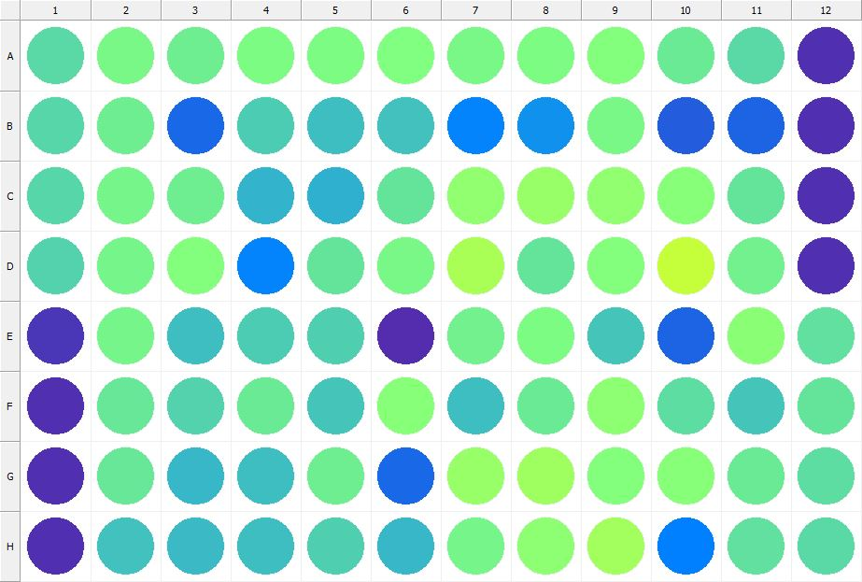

|  |
| --- |
| **Results for Tim_CTB(1) - channel 1 (RFU)** |

|  |  |  |  |  |  |  |  |  |  |  |  |  |
| --- | --- | --- | --- | --- | --- | --- | --- | --- | --- | --- | --- | --- |
|  | 01 | 02 | 03 | 04 | 05 | 06 | 07 | 08 | 09 | 10 | 11 | 12 |
| A | 145780 | 166496 | 160265 | 169032 | 170052 | 172495 | 166557 | 168865 | 173420 | 157949 | 145240 | 32076 |
| B | 144354 | 160755 | 70618 | 136111 | 127460 | 129027 | 88788 | 96934 | 166917 | 63343 | 67779 | 31549 |
| C | 144085 | 163767 | 159705 | 120712 | 118421 | 153295 | 183516 | 187952 | 184127 | 176802 | 152985 | 32941 |
| D | 142134 | 164985 | 174861 | 89208 | 152152 | 166759 | 200502 | 153151 | 175070 | 217102 | 162406 | 33563 |
| E | 38101 | 164348 | 127321 | 137020 | 138861 | 30782 | 162880 | 169205 | 131775 | 67661 | 178313 | 150303 |
| F | 33579 | 154628 | 141733 | 156744 | 131317 | 175697 | 128518 | 156921 | 181329 | 148840 | 132301 | 154203 |
| G | 33230 | 154864 | 123270 | 128502 | 160070 | 70313 | 187509 | 192363 | 173589 | 175382 | 157245 | 149293 |
| H | 32169 | 129231 | 124629 | 127362 | 138929 | 123639 | 165554 | 181789 | 194910 | 85746 | 150706 | 146425 |

|  |  |
| --- | --- |
| **Plate information** | |
|  | |
| **Plate** | 8 |
| **Repeat** | 1 |
| **Barcode** |  |
| **Measured height** | 14.78 |
| **Inside temperature at start** | 23.83 |
| **Inside temperature at end** | 23.85 |
| **Humidity at start** | 14.6 |
| **Humidity at end** | 15.7 |
| **Ambient temperature at start** | 23.54 |
| **Ambient temperature at end** | 23.85 |
| **Group** | 1 |
| **Label** | Tim_CTB(1) |
| **ScanX** | 0 |
| **ScanY** | 0 |
| **Measinfo** | De=1st Ex=Top Em=Top Wdw=N/A (14) |
| **Kinetics** | 0 |
| **Measurement date** | 11/21/2022 2:02:17 PM |
|  | |

|  |
| --- |
| **Background information** |
| Legend:  HDR1 - Plate  HDR2 - Label  HDR3 - Result  HDR4 - Signal  HDR5 - Flashes/Time  HDR6 - Meastime  HDR7 - MeasInfo |
| HDR1 HDR2 HDR3 HDR4 HDR5 HDR6 HDR7  8 Tim_CTB 0 1047 1 00:00:00.000 De=1st Ex=Top Em=Top Wdw=N/A (14) |
|  |

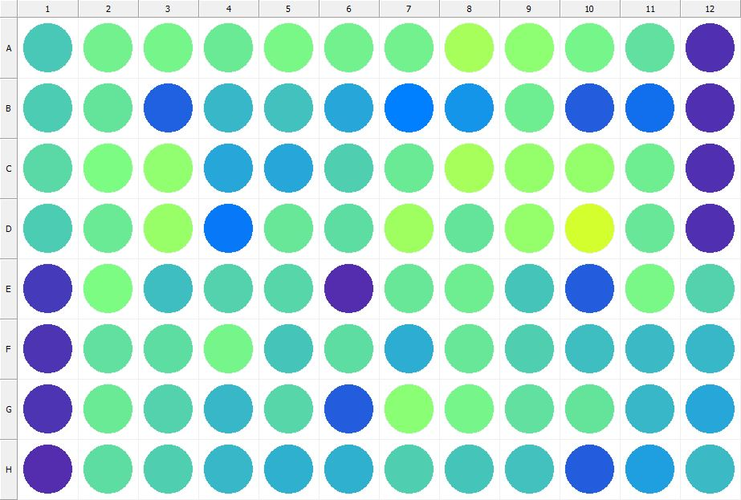

|  |
| --- |
| **Results for Tim_CTB(1) - channel 1 (RFU)** |

|  |  |  |  |  |  |  |  |  |  |  |  |  |
| --- | --- | --- | --- | --- | --- | --- | --- | --- | --- | --- | --- | --- |
|  | 01 | 02 | 03 | 04 | 05 | 06 | 07 | 08 | 09 | 10 | 11 | 12 |
| A | 133839 | 162925 | 165383 | 156965 | 166438 | 161899 | 161415 | 197943 | 180085 | 165713 | 150511 | 32511 |
| B | 135809 | 153581 | 65750 | 124052 | 129783 | 111636 | 85460 | 99860 | 160160 | 63700 | 73405 | 31509 |
| C | 147228 | 168375 | 183830 | 111236 | 111301 | 138271 | 157257 | 198024 | 185859 | 185722 | 161113 | 32329 |
| D | 136686 | 158826 | 188660 | 81464 | 156167 | 147852 | 193331 | 154125 | 185422 | 228312 | 156049 | 32804 |
| E | 39505 | 170288 | 128232 | 140527 | 142802 | 29829 | 155649 | 160973 | 131684 | 62696 | 167218 | 141625 |
| F | 34291 | 150395 | 147421 | 165836 | 131409 | 149362 | 117069 | 154903 | 138915 | 126425 | 124123 | 123413 |
| G | 33848 | 157741 | 141259 | 123039 | 144248 | 63397 | 179579 | 163593 | 151851 | 152607 | 122903 | 112028 |
| H | 31237 | 147604 | 138411 | 123181 | 118506 | 118269 | 139848 | 131559 | 129962 | 63695 | 106921 | 125894 |

|  |  |
| --- | --- |
| **Plate information** | |
|  | |
| **Plate** | 9 |
| **Repeat** | 1 |
| **Barcode** |  |
| **Measured height** | 14.78 |
| **Inside temperature at start** | 23.83 |
| **Inside temperature at end** | 23.95 |
| **Humidity at start** | 15.4 |
| **Humidity at end** | 15.4 |
| **Ambient temperature at start** | 23.83 |
| **Ambient temperature at end** | 23.75 |
| **Group** | 1 |
| **Label** | Tim_CTB(1) |
| **ScanX** | 0 |
| **ScanY** | 0 |
| **Measinfo** | De=1st Ex=Top Em=Top Wdw=N/A (14) |
| **Kinetics** | 0 |
| **Measurement date** | 11/21/2022 2:02:58 PM |
|  | |

|  |
| --- |
| **Background information** |
| Legend:  HDR1 - Plate  HDR2 - Label  HDR3 - Result  HDR4 - Signal  HDR5 - Flashes/Time  HDR6 - Meastime  HDR7 - MeasInfo |
| HDR1 HDR2 HDR3 HDR4 HDR5 HDR6 HDR7  9 Tim_CTB 0 934 1 00:00:00.000 De=1st Ex=Top Em=Top Wdw=N/A (14) |
|  |

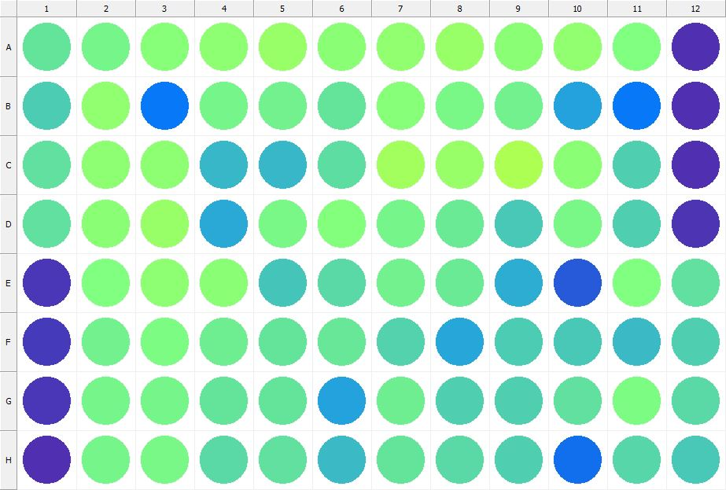

|  |
| --- |
| **Results for Tim_CTB(1) - channel 1 (RFU)** |

|  |  |  |  |  |  |  |  |  |  |  |  |  |
| --- | --- | --- | --- | --- | --- | --- | --- | --- | --- | --- | --- | --- |
|  | 01 | 02 | 03 | 04 | 05 | 06 | 07 | 08 | 09 | 10 | 11 | 12 |
| A | 152164 | 163901 | 176559 | 181964 | 187532 | 178557 | 182516 | 187862 | 178451 | 182123 | 172326 | 32864 |
| B | 137902 | 182647 | 82283 | 164260 | 162588 | 152154 | 177420 | 166743 | 163000 | 108633 | 82239 | 32337 |
| C | 151895 | 179845 | 180988 | 121922 | 122277 | 149191 | 194139 | 187690 | 202043 | 178062 | 139152 | 32436 |
| D | 150087 | 178626 | 188333 | 114123 | 167390 | 172940 | 163638 | 157034 | 135196 | 166825 | 138760 | 33878 |
| E | 36638 | 171853 | 182005 | 179120 | 131274 | 146072 | 162119 | 157068 | 115066 | 60440 | 171535 | 150377 |
| F | 38344 | 162607 | 170277 | 159661 | 152026 | 154572 | 142616 | 111500 | 136035 | 134075 | 126329 | 138839 |
| G | 36370 | 164596 | 164088 | 154038 | 153522 | 108530 | 159338 | 138167 | 138224 | 151481 | 168708 | 144976 |
| H | 31692 | 165226 | 167106 | 145589 | 151464 | 126336 | 152434 | 145648 | 139977 | 73984 | 144794 | 135376 |

|  |  |
| --- | --- |
| **Plate information** | |
|  | |
| **Plate** | 10 |
| **Repeat** | 1 |
| **Barcode** |  |
| **Measured height** | 14.78 |
| **Inside temperature at start** | 23.93 |
| **Inside temperature at end** | 23.93 |
| **Humidity at start** | 15.4 |
| **Humidity at end** | 15.2 |
| **Ambient temperature at start** | 23.73 |
| **Ambient temperature at end** | 23.73 |
| **Group** | 1 |
| **Label** | Tim_CTB(1) |
| **ScanX** | 0 |
| **ScanY** | 0 |
| **Measinfo** | De=1st Ex=Top Em=Top Wdw=N/A (14) |
| **Kinetics** | 0 |
| **Measurement date** | 11/21/2022 2:03:39 PM |
|  | |

|  |
| --- |
| **Background information** |
| Legend:  HDR1 - Plate  HDR2 - Label  HDR3 - Result  HDR4 - Signal  HDR5 - Flashes/Time  HDR6 - Meastime  HDR7 - MeasInfo |
| HDR1 HDR2 HDR3 HDR4 HDR5 HDR6 HDR7  10 Tim_CTB 0 1042 1 00:00:00.000 De=1st Ex=Top Em=Top Wdw=N/A (14) |
|  |

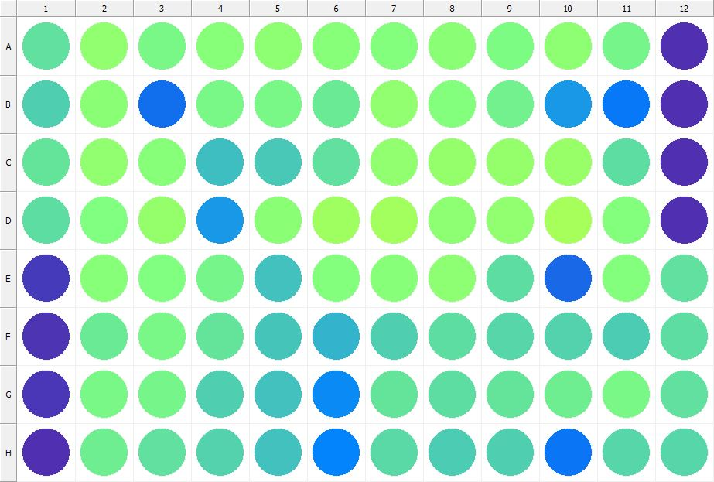

|  |
| --- |
| **Results for Tim_CTB(1) - channel 1 (RFU)** |

|  |  |  |  |  |  |  |  |  |  |  |  |  |
| --- | --- | --- | --- | --- | --- | --- | --- | --- | --- | --- | --- | --- |
|  | 01 | 02 | 03 | 04 | 05 | 06 | 07 | 08 | 09 | 10 | 11 | 12 |
| A | 150829 | 183227 | 167463 | 176344 | 181271 | 175591 | 174873 | 179091 | 170262 | 181638 | 164718 | 32088 |
| B | 140069 | 179232 | 75138 | 166600 | 166228 | 157526 | 184095 | 174746 | 163377 | 101199 | 81549 | 32551 |
| C | 152744 | 182239 | 176006 | 127207 | 135024 | 151681 | 183807 | 186238 | 185104 | 188265 | 147782 | 32635 |
| D | 147308 | 171832 | 185356 | 102484 | 177470 | 191512 | 193687 | 180162 | 182373 | 196145 | 172926 | 33392 |
| E | 39298 | 176712 | 172542 | 165370 | 129722 | 174233 | 177410 | 181176 | 149276 | 70126 | 173528 | 150045 |
| F | 33663 | 157925 | 166224 | 153428 | 132297 | 120419 | 139792 | 147548 | 144364 | 141269 | 136245 | 147983 |
| G | 36468 | 166964 | 164683 | 139079 | 130917 | 93472 | 153910 | 148871 | 153695 | 160919 | 166008 | 150504 |
| H | 32864 | 158992 | 151200 | 141804 | 130576 | 89243 | 147033 | 136925 | 138542 | 79229 | 144462 | 144482 |

|  |  |
| --- | --- |
| **Plate information** | |
|  | |
| **Plate** | 11 |
| **Repeat** | 1 |
| **Barcode** |  |
| **Measured height** | 14.78 |
| **Inside temperature at start** | 23.93 |
| **Inside temperature at end** | 23.93 |
| **Humidity at start** | 15.1 |
| **Humidity at end** | 15.1 |
| **Ambient temperature at start** | 23.64 |
| **Ambient temperature at end** | 23.54 |
| **Group** | 1 |
| **Label** | Tim_CTB(1) |
| **ScanX** | 0 |
| **ScanY** | 0 |
| **Measinfo** | De=1st Ex=Top Em=Top Wdw=N/A (14) |
| **Kinetics** | 0 |
| **Measurement date** | 11/21/2022 2:04:20 PM |
|  | |

|  |
| --- |
| **Background information** |
| Legend:  HDR1 - Plate  HDR2 - Label  HDR3 - Result  HDR4 - Signal  HDR5 - Flashes/Time  HDR6 - Meastime  HDR7 - MeasInfo |
| HDR1 HDR2 HDR3 HDR4 HDR5 HDR6 HDR7  11 Tim_CTB 0 1133 1 00:00:00.000 De=1st Ex=Top Em=Top Wdw=N/A (14) |
|  |

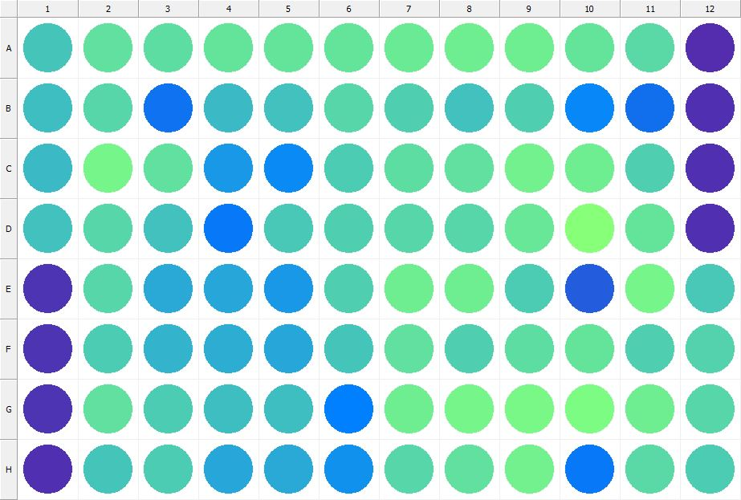

|  |
| --- |
| **Results for Tim_CTB(1) - channel 1 (RFU)** |

|  |  |  |  |  |  |  |  |  |  |  |  |  |
| --- | --- | --- | --- | --- | --- | --- | --- | --- | --- | --- | --- | --- |
|  | 01 | 02 | 03 | 04 | 05 | 06 | 07 | 08 | 09 | 10 | 11 | 12 |
| A | 132672 | 151767 | 148057 | 153417 | 152861 | 153204 | 156584 | 160970 | 160068 | 154113 | 146153 | 31135 |
| B | 127364 | 143738 | 76140 | 124763 | 130192 | 144343 | 140212 | 130520 | 138707 | 91553 | 73771 | 31910 |
| C | 125453 | 164304 | 151912 | 101975 | 93519 | 137951 | 147416 | 151210 | 162242 | 161155 | 138655 | 33035 |
| D | 128743 | 143749 | 129372 | 80087 | 134258 | 138159 | 142812 | 144909 | 155915 | 177125 | 152929 | 33148 |
| E | 35707 | 144944 | 113289 | 111647 | 101007 | 139861 | 158922 | 159150 | 137876 | 62689 | 163576 | 135002 |
| F | 35028 | 136894 | 120675 | 116353 | 112323 | 131201 | 151673 | 138727 | 149041 | 153431 | 139006 | 142410 |
| G | 34488 | 149689 | 137789 | 128491 | 127668 | 86948 | 159590 | 165369 | 166202 | 168167 | 158955 | 144260 |
| H | 31758 | 133168 | 137665 | 111774 | 114252 | 97168 | 143079 | 150629 | 163199 | 81458 | 145711 | 137365 |

|  |  |
| --- | --- |
| **Plate information** | |
|  | |
| **Plate** | 12 |
| **Repeat** | 1 |
| **Barcode** |  |
| **Measured height** | 14.78 |
| **Inside temperature at start** | 23.93 |
| **Inside temperature at end** | 23.93 |
| **Humidity at start** | 15.1 |
| **Humidity at end** | 15.1 |
| **Ambient temperature at start** | 23.64 |
| **Ambient temperature at end** | 23.54 |
| **Group** | 1 |
| **Label** | Tim_CTB(1) |
| **ScanX** | 0 |
| **ScanY** | 0 |
| **Measinfo** | De=1st Ex=Top Em=Top Wdw=N/A (14) |
| **Kinetics** | 0 |
| **Measurement date** | 11/21/2022 2:05:01 PM |
|  | |

|  |
| --- |
| **Background information** |
| Legend:  HDR1 - Plate  HDR2 - Label  HDR3 - Result  HDR4 - Signal  HDR5 - Flashes/Time  HDR6 - Meastime  HDR7 - MeasInfo |
| HDR1 HDR2 HDR3 HDR4 HDR5 HDR6 HDR7  12 Tim_CTB 0 1059 1 00:00:00.000 De=1st Ex=Top Em=Top Wdw=N/A (14) |
|  |

|  |  |
| --- | --- |
|  | |
| **Basic assay information** | |
| **Assay ID** | 24220 |
| **Assay Started** | 11/21/2022 1:56:47 PM |
| **Assay Finished** | 11/21/2022 2:05:20 PM |
| **Assay Exported** | 11/21/2022 2:07:38 PM |
| **Protocol ID** | 100568 |
| **Protocol Name** | Copy of 96well-CTB_Tim |
| **Serial#** | 1020141 |
|  | |
|  | |
|  | |
| **Protocol information** | |
| **Protocol:** | |
| **Protocol name** | Copy of 96well-CTB_Tim |
| **Number of assay repeats** | 1 |
| **Start assay repeat each** | N/A |
| **Number of plate repeats** | 1 |
| **Start plate repeat each** | N/A |
| **Is label meas. height used** | Yes |
| **Height of measurement** | Defined in label |
| **Is gripper height used** | No |
| **Mode of measurement** | By Rows, bi-directional |
| **Rotated plate** | No |
| **Soft move** | No |
| **Protocol notes** |  |
|  | |
| **Plate type:** | |
| **Name of the plate type** | 96 General |
| **Number of rows** | 8 |
| **Number of columns** | 12 |
| **Number of the wells in the plate** | 96 |
| **Height of the plate** | 14.35 mm |
|  | |
| **Coordinates of corners:** | |
| **96 General + Tim_CTB** | |
| 14.38 mm x------------------------------------------------------ x 113.38 mm  11.24 mm 11.24 mm | |
| 14.38 mm x------------------------------------------------------ x 113.38 mm  74.24 mm 74.24 mm | |
|  | |
|  | |

|  |  |
| --- | --- |
| **Platemap:** | |
| **Plate** | 1 |
| **Group** | 1 |
|  | |

|  |  |  |  |  |  |  |  |  |  |  |  |  |
| --- | --- | --- | --- | --- | --- | --- | --- | --- | --- | --- | --- | --- |
|  | **01** | **02** | **03** | **04** | **05** | **06** | **07** | **08** | **09** | **10** | **11** | **12** |
| **A** | - | - | - | - | - | - | - | - | - | - | - | - |
| **B** | - | - | - | - | - | - | - | - | - | - | - | - |
| **C** | - | - | - | - | - | - | - | - | - | - | - | - |
| **D** | - | - | - | - | - | - | - | - | - | - | - | - |
| **E** | - | - | - | - | - | - | - | - | - | - | - | - |
| **F** | - | - | - | - | - | - | - | - | - | - | - | - |
| **G** | - | - | - | - | - | - | - | - | - | - | - | - |
| **H** | - | - | - | - | - | - | - | - | - | - | - | - |

|  |  |
| --- | --- |
|  | |
| **-** | Undefined |
|  | |
|  | |

|  |  |
| --- | --- |
| **Calculations:** | |
| **No calculations.** | |
|  | |
| **Auto export parameters:** | |
| **Export format** | Plate2 |
| **Include basic assay information** | Yes |
| **Place assay information at** | End of file |
| **Include basic plate information** | Yes |
| **Place plate information at** | Beginning of plate |
| **Include protocol information** | Yes |
| **Protocol info level** | Large |
| **Include error and warning information** | Yes |
| **Include background information** | Yes |
| **Add plate number to the file name** | Yes |
| **Each plate to separate file** | No |
| **Field separator to use** | System |
| **File name format** | <DefaultDataFolder>\<Date>\<ProtocolName>_<AssayID>.csv |
|  | |
| **Operations:** | |
| Plate 1  Group 1  Measurement  Label..................................................... Tim_CTB(1) | |
| **Labels:** | |
| **Tim_CTB** | 4000137 |
| **Top mirror** | General |
| **Bottom mirror** | N/A |
| **Exc. filter** | Photometric 530 |
| **Using of excitation filter** | Top |
| **2nd exc. filter** | N/A |
| **Using of 2nd excitation filter** | Top |
| **Ems. filter** | Photometric 590 |
| **2nd ems. filter** | N/A |
| **Measurement height** | 6.5 mm |
| **Number of flashes** | 1 |
| **Number of flashes integrated** | 1 |
| **PMT gain** | 1 |
| **Excitation light** | 100% |
| **Reference excitation light** | 100% |
| **Emission light** | 100% |
| **Reference AD gain** | 4 |
| **Reference signal** | 383728 |
| **Last edited** | 2/11/2019 10:20:00 AM |
| **Last edited by** | EnVision |
| **Factory preset** | No |
|  | |
| **Filters:** | |
| **Photometric 530** | 310 |
| **Filter type** | Excitation |
| **Description** | P530 CWL=530nm BW=8nm Tmin=55% |
| **Used with** | Absorbance,DELFIA - Time-resolved Fluorescence,Fluorescence Intensity,Fluorescence Polarization,LANCE - Time-resolved Fluorescence |
| **Last edited** | 8/19/2014 4:24:21 PM |
| **Last edited by** | Installation |
| **Factory preset** | Yes |
|  | |
| **Photometric 590** | 314 |
| **Filter type** | Excitation |
| **Description** | P590 CWL=590nm BW=8nm Tmin=40% |
| **Used with** | Absorbance,DELFIA - Time-resolved Fluorescence,Fluorescence Intensity,Fluorescence Polarization,LANCE - Time-resolved FluorescenceAbsorbance,DELFIA - Time-resolved Fluorescence,Fluorescence Intensity,Fluorescence Polarization,LANCE - Time-resolved Fluorescence |
| **Last edited** | 8/19/2014 4:24:21 PM |
| **Last edited by** | Installation |
| **Factory preset** | Yes |
|  | |
| **Mirror modules:** | |
| **General** | 401 |
| **Used by** | Top |
| **Dual** | No |
| **Bias** | No |
| **Description** | BS50 |
| **Used with** | Luminescence,DELFIA - Time-resolved Fluorescence,Fluorescence Intensity,Fluorescence Polarization,LANCE - Time-resolved Fluorescence |
| **Last edited** | 8/19/2014 4:24:21 PM |
| **Last edited by** | Installation |
| **Factory preset** | Yes |
|  | |
| **Instrument:** | |
| **Serial number** | 1020141 |
| **Nickname** | EnVision |
|  | |
|  | |
|  | |
|  | |
| **Notifications:** | |
| Assay notifications:  INFO: Assay aborted at plate 12 plate repeat 1 and well H01. There may be missing results | |
|  | |
|  | |

|  |
| --- |
|  |
| **Exported with EnVision Workstation version 1.13.3009.1409** |